1. Create Edit from admin panel and teachers panel within the menu of questionnaire.

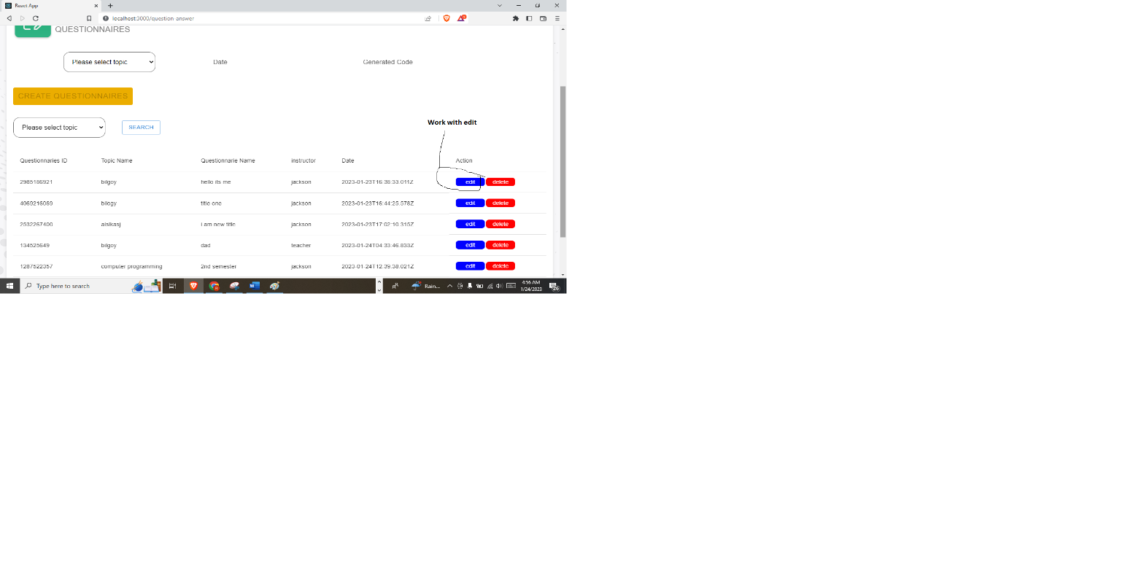

1. Change the design from the result menu into like this.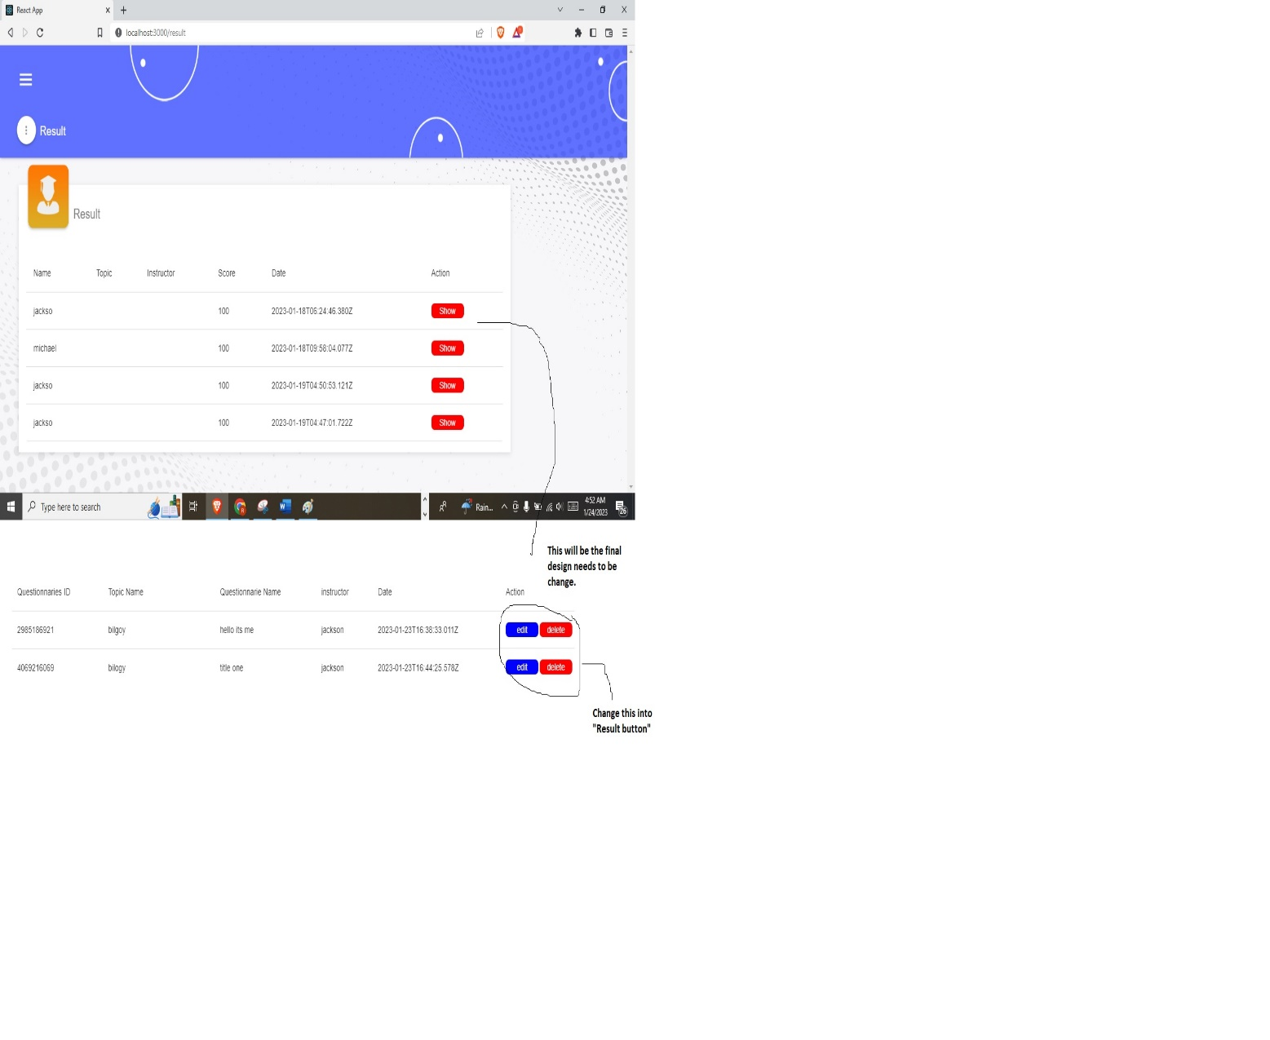
2. Add the print button to the table list inside of the result menu page.

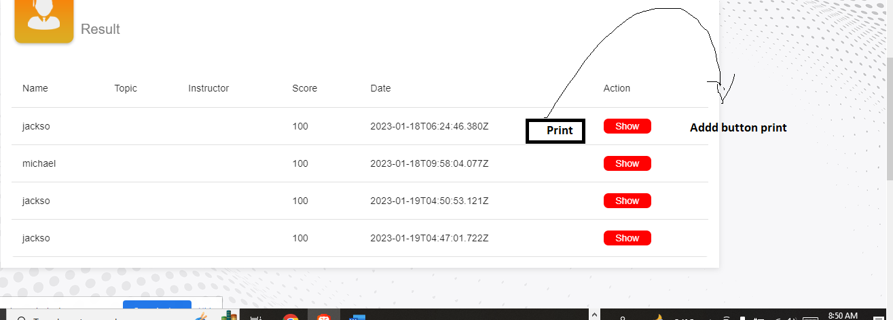

1. Base on case number 3. After clicking the button print.. The next print should be look like this one..

